# Let’s communicate

## PART A: The construction of a model with only your data

*1. Please provide a description of the initial data set you brought to class. What were the objects, how many ... and why you chose those specific objects. Provide an image of each distinct object.*

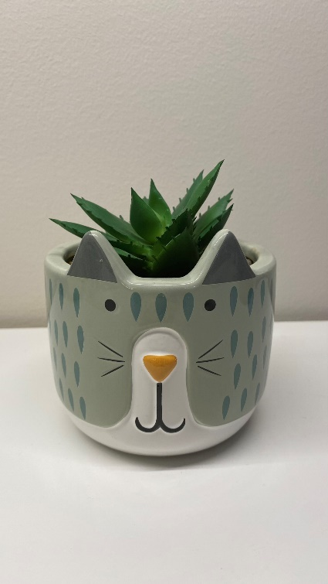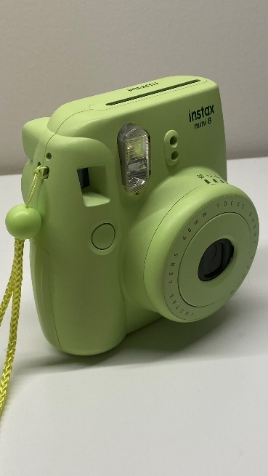🡨 My first object was a green *instax* camera. I chose this object because it has a lot of details on it. (50 pictures)

My second object was a fake plant in a cat pot. I chose this object because there are a lot of different textures and colors in it. (50 pictures) 🡪

Then, I took pictures of 50 other random objects such as pencils, boxes, hats, headphones, etc.

*2. What was the purpose of the task you were asked to do in class?*

We had to create a machine learning model with Edge Impulse. The model’s purpose is to recognize and classify objects. We train the model with our images that we classified, then test the model by seeing if it correctly classifies each object in its category.

*3. Describe in a series of steps what you did to complete the initial task in class.*

1. Upload our data (the images) to Edge Impulse. Label the images depending on the object that they represent.

2. Visualize the data in the data explorer.

3. Test the model.

*4. How well did your dataset do in terms of Accuracy, Precision and Recall?*

My dataset had a pretty good accuracy of 89.66%.

*5. Take screen grabs of the graphs available through the Feature Explorer for both the training and test/ live classification sets. Discuss the graphs in detail.*

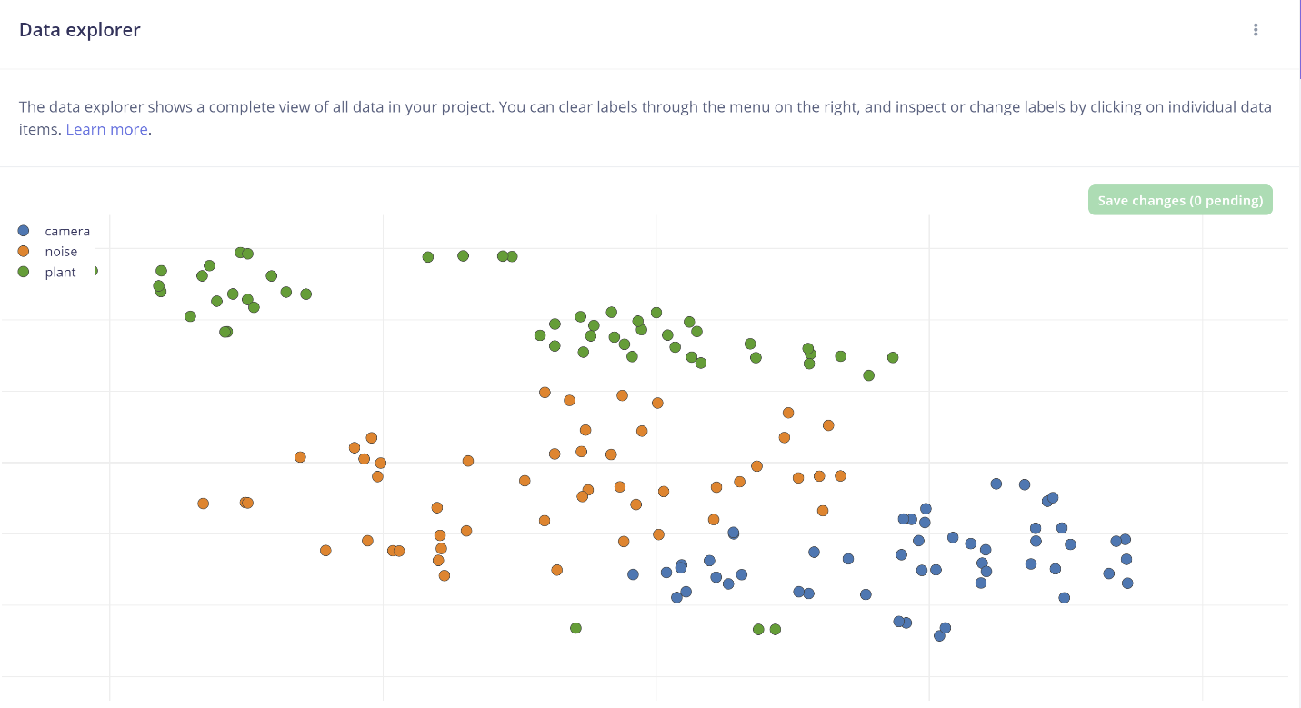

In the Data explorer, the data seems relatively accurately distributed. A few green dots (plant) appear near the blue dots (camera). According to this view, some plant pictures look like camera pictures.

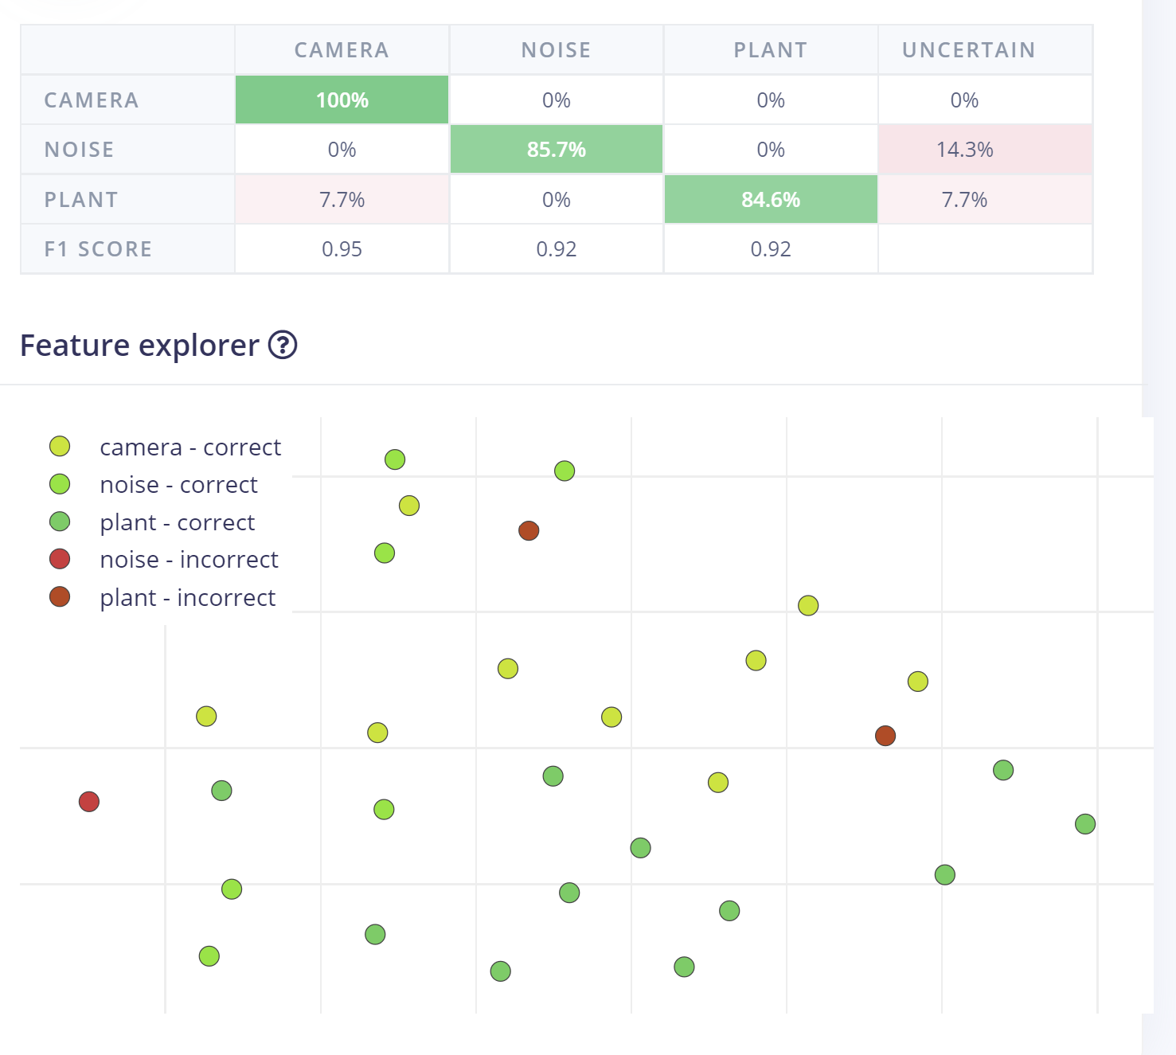

In the Feature explorer, we can easily spot that some mistakes were made with plant and noise pictures. The camera had a 100% accuracy, which is excellent. The noise had a 85.7% accuracy, which is pretty good. Finally, the plant had a 84.6% accuracy, which is also good.

*6. Provide brief postulations for how you think you could get your model to perform better. What does better mean?*

I could input more images of my two objects from different angles, zooms and backgrounds to improve the accuracy of the model. *Better* means that the model accurately assigns the correct label to an object.